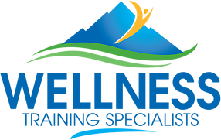

GREAT WEST PHYSICAL EDUCATION SUMMIT
Thursday, August 8, 2019, 7:30 - 3:30
Gold Crown Field House, 150 South Harlan Street, Lakewood, Co., 80226

Description
Gopher Sport, in partnership with Wellness Training Specialists and Jefferson County Public Schools is proud to announce the 3rd Annual Great West Physical Education Summit.

Come join other physical education professionals and students from around the Rocky Mountain Region including Colorado, Utah, Wyoming, Kansas, Nebraska and New Mexico for a fun filled day of quality professional development just in time to “kick start” the new school year. Come learn new ideas, games, activities and strategies you can put in place on day one with your students!

The Great West P.E. Summit includes an “All Star” line-up of presenters including past and present Teachers-of-the-Year as well as national and international speakers. Example sessions include:

- Cardio Drumming
- Teaching a 4-Part Lesson – Rhythms & More
- Teacher Self Care: Strategies for Maintaining Mental and Emotional Health
- The Greatest Fitness Show for K-12
- P.E. Power: Unlock the Potential of Your Program
- Making P.E. Meaningful and Motivating
- NutriPlay: The Active Way to Teach Nutrition
- Physical Education for the Win… Manage, Move and Motivate!

Registration Information
Additional information and registration details for this free event can be found by following this link.

